Getting to a Soccer Field in New York Can Be Harder Than You Think
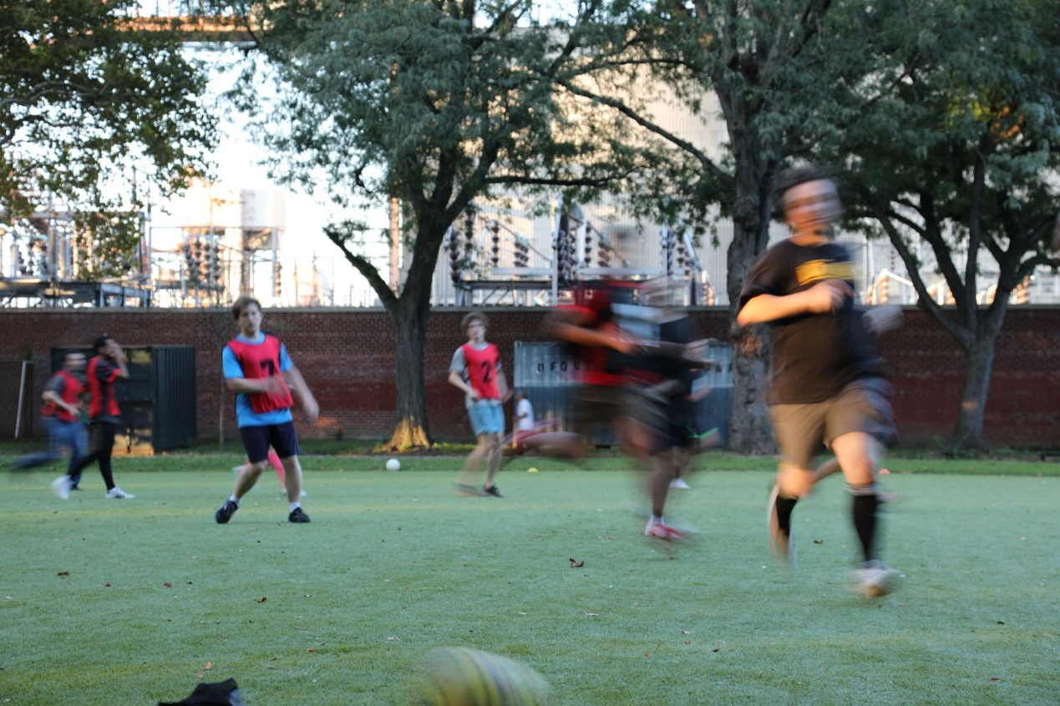
Cover photo

When the World Cup came to New York City this summer, Mayor Zohran Mamdani touted the city as a natural home for the world’s game: “there is no better place on earth to host the world’s game than a city where every nation is already represented, where every language is spoken and every cuisine is eaten.” But beyond this representational link lies a more tangible question: what does soccer actually look like in the everyday lives of immigrant New Yorkers?

A 2024 New York Times report from Flushing Meadows Corona Park captured that world up close. Regardless of weather, some 100 community-organized league games are played across more than 20 fields on Sundays. Around the games, a larger social world takes shape as people spend the day watching, eating, talking and reconnecting. For a lot of immigrant New Yorkers, soccer offers a piece of familiarity in a new city and a community that can make it feel a little more like home.

Getting there, though, is another matter. How easy is it to actually reach a soccer field?

For someone whose only day off is Sunday, or for families traveling with young children, a long trip to soccer fields can determine whether they are going at all. A field can become a gathering place for immigrant communities only if people can reach it conveniently.
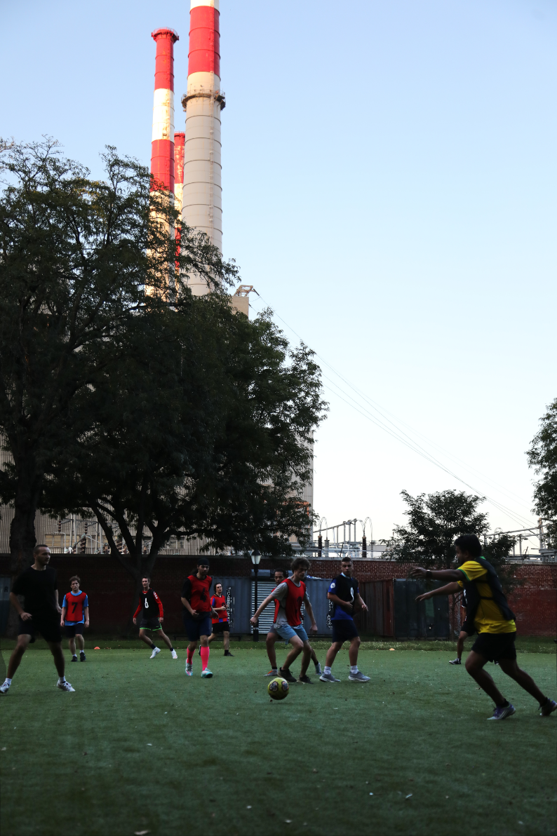
A Sunday evening pickup game at Queensbridge Park

One simple way to think about that access is through the idea of the “15-minute city,” a planning concept developed around a simple goal: people should be able to reach most places that are part of their everyday life within about a 15-minute walk or bike ride of home. That can mean a grocery store, a school or a park. But what about a soccer field? Across New York, how many people actually have one within a 15-minute walk from home? A look at two neighborhoods shows just how different the answer can be.

Take Elmhurst, Queens, for example. More than 100,000 people live in the neighborhood, but only 8 percent are within a 15-minute walk of a soccer field. In Gramercy, Manhattan, on the other hand, with the population of around 26,000, and yet 75.2 percent of residents live within a 15-minute walk of one. Elmhurst and Gramercy sit at opposite ends of the spectrum, but the mismatch between population and soccer access extends across the city. More people living in a neighborhood does not necessarily mean more people have a field close to home. Across New York, some neighborhoods with more population have little access, while much smaller ones are comparatively well served.

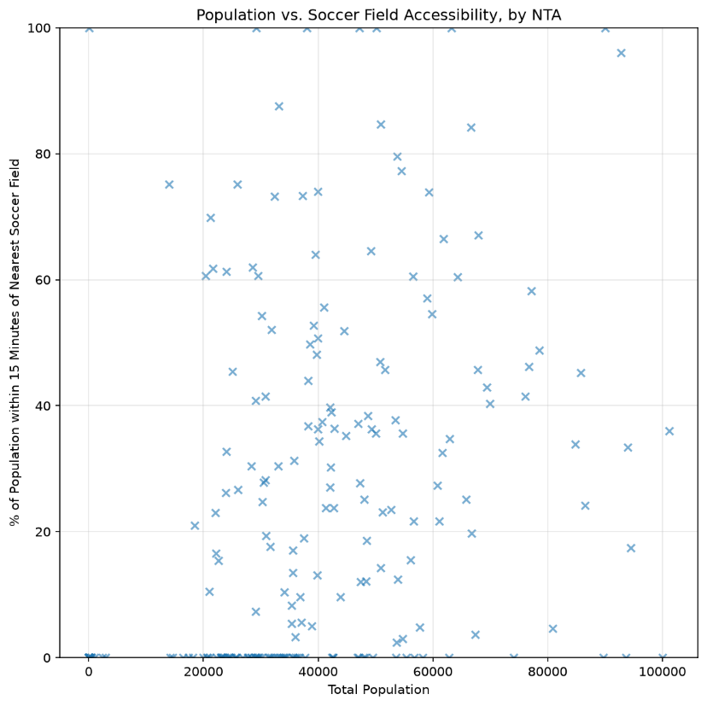
There seems to be little correlation between NTA population and soccer field accessibility

But that uneven geography does not affect every New Yorker in the same way. Among the communities caught in the mismatch are many of the immigrant neighborhoods where soccer has taken on a life far beyond the field.

Zoom out from the individual neighborhoods and the pattern emerges. Across the city, neighborhoods with larger foreign-born populations often appear alongside some of the lowest levels of walking access to soccer fields. For a game that means so much to immigrant communities, having a field close to home is far from guaranteed.

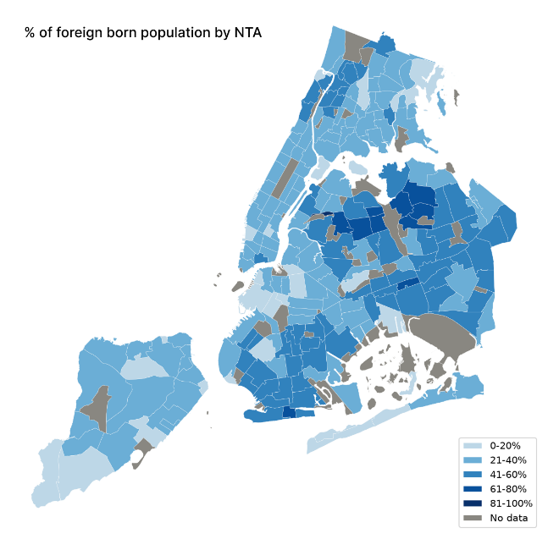
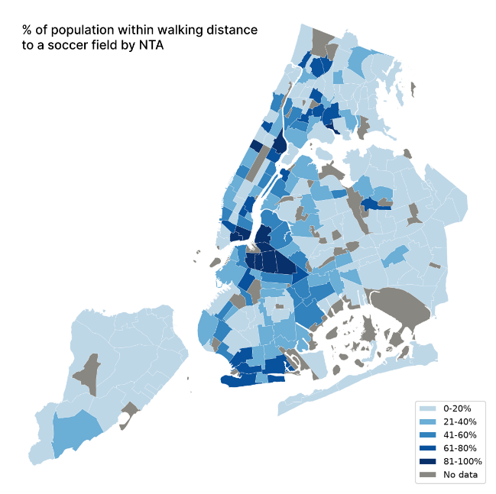
Side by side comparison of % of population within walking distance to a soccer field by NTA and % of foreign born population by NTA

Of course, putting a soccer field anywhere in New York is complicated. A full-size pitch takes up a lot of land in a city where every square foot is contested. Real estate, the amount and shape of existing parkland, neighborhood density and competing demands for public space all play a role, alongside decades of decisions about what gets built, renovated or replaced, and today’s uneven distribution begins to make more sense. The Sunday games at Flushing Meadows show what can happen once that space exists. It seems as though, for immigrant New Yorkers, the sport they love may travel easily across international borders as a global media spectacle, but the space to play it hardly moves across the established socio-economic structure of the city.

The city has tried to close some of that gap. The New York City Soccer Initiative began in 2016 and has since built 50 mini-pitches across the five boroughs to expand access to free soccer. Now the initiative is expanding again. Its second phase, “26 for 26,” is adding 26 more mini-pitches across New York in the lead-up to the 2026 World Cup. The first opened at P.S. 211 in Queens in June 2025, turning an underused stretch of concrete into a new place to play.
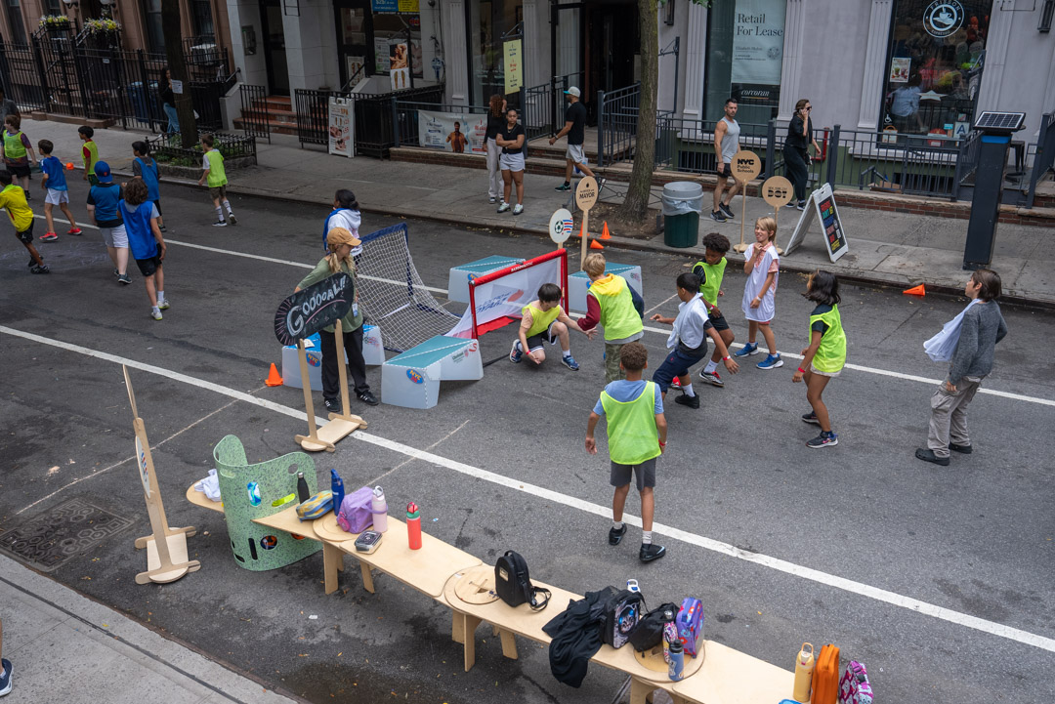
Students take over the street for a game of soccer as part of Street Lab’s Soccer Streets program. Photo: Street Lab

In some neighborhoods, however, a dedicated place to play is not easy to find. This spring, the nonprofit Street Lab began working with 50 public schools to close streets to traffic and turn them into places where students, families and neighbors can play soccer together. The program launched this May outside P.S. 32 in the Bronx. It was one of the first schools to take part in Soccer Streets. The surrounding neighborhood is also home to a substantial immigrant population. But when a school has to close its own street to give children somewhere to kick a ball, it shows a lot is still missing…

